**KWAME NKRUMAH UNIVERSITY OF SCIENCE AND TECHNOLOGY**

**COLLEGE OF SCIENCE**

**FACULTY OF PHYSICAL SCIENCES**

**DEPARTMENT OF PHYSICS**



**GROUP B4**

**TITLE: INTEGRATING GHANAIAN SCENERY AND LANDSCAPE INTO A FLIGHT SIMULATOR. CASE STUDY - KUMASI.**

**SUPERVISORS: DR. A. BRITWUM AND DR. M. K. E. DONKOR**

**Group Members**

**Name: Index No:**

**OWOO MARVEL NII KWARTEI 9455619**

**AZAMETSI ISHMAEL KWEKU 9448219**

**AARON TEYE PINTO 9456719**

**GIDISU PRINCE 9451119**

# **DECLARATION**

We declare that this work is our original work submitted as partial fulfilment for a degree course in Bsc Physics in the Kwame Nkrumah University of Science and Technology. This work has been presented for the award of any other degree in this or any other university except where references are made to the work of others.



OWOO MARVEL NII KWARTEI ……………………… 11/09/2023

Student name signature date

AZAMETSI ISHMAEL KWEKU ……………………… 11/09/2023

Student name signature date

GIDISU PRINCE  11/09/2023

Student name signature date

AARON TEYE PINTO  11/09/2023

Student name signature date

Dr A. BRITWUM …… 11/09/2023

Supervisor signature date

DR M.K.E DONKOR  11/09/2023

Supervisor signature date

PROF. R.Y. TAMAKLOE  11/09/2023

Head of Department signature date

# **ACKNOWLEDGEMENT**

Our deepest gratitude is to the Almighty God and then to our supervisors Dr A. Britwum and Dr M.K.E Donkor.

We appreciate the support and God richly bless you.

# **ABSTRACT**

This thesis presents the successful completion of a comprehensive project aimed at generating highly accurate and intricate 3D models of the Kwame Nkrumah University of Science and Technology (KNUST) campus and the Kumasi airport region for integration into the X-Plane flight simulator. This initiative seamlessly integrates simulation, modelling, and satellite image processing techniques. The investigation starts with the extraction of satellite pictures, precisely defining the areas of interest using programs like Ortho4XP The 3D modelling was then carried out utilizing programs like World Editor and Blender. A model of the Kumasi airport area has been created, completed with buildings, taxiways, runways, and lights. Similar to this, the KNUST campus is faithfully replicated down to the roads, buildings, and other notable elements. Applying geometric optics principles to lighting and reflection simulation improves realism. Imperfections are found and fixed during testing in the X-Plane simulator, assuring correct representation and operation. The project’s applicability and potential benefits for flight training and education have been confirmed through interviews with pilots and aeronautical engineering students. In conclusion, this study portrays how the combination of simulation, architectural modelling, and satellite image processing techniques have been utilized to produce a realistic 3D environment.

**Table of Contents**

**DECLARATION** i

**ACKNOWLEDGEMENT** ii

**ABSTRACT** iii

**LIST OF FIGURES** vi

**CHAPTER 1** 1

**INTRODUCTION** 1

**1.1 Background study.** 1

**1.2 Main Objective** 3

**1.3 Specific Objectives** 3

**1.5 Justification** 4

**1.6 Limitations of Study** 5

**CHAPTER 2** 6

**THEORY (Literature Review)** 6

**2.1 Importance of Modelling in Flight Simulation** 6

**2.2 Utilizing Satellite Imagery for Realistic Scenery** 6

**2.3 Key Factors in Satellite Imagery Analysis** 7

**2.4 Requirements for 3D modelling of Objects** 7

**2.5 Evolution Scenery Building in Flight Simulation** 9

**CHAPTER 3** 11

**METHODOLOGY** 11

**3.1 Finding Out How Relevant This Work is.** 11

**3.2 Marking Out and Extraction of Satellite Images.** 12

**3.3 D Modelling of satellite images.** 13

**3.4 Examining the geometric optics in relation to the scenery environment built.** 14

**3.5 Testing and Debugging of 3D Structure.** 15

**3.6 Simulation of Finalized Works** 15

**CHAPTER 4** 17

**4.1 Outcome of Survey and Interviews** 17

**4.2 Imported Satellite Images** 20

**4.3 Results from The 3D modelling in WED and Blender** 22

**4.4 Geometric Optics Evaluation of Modelled Work** 25

**4.5 Discussion On The Testing and Debugging of The Work** 25

**CHAPTER 5** 29

**5.1 CONCLUSION** 29

**5.2 RECOMMENDATIONS** 30

**REFERENCES** 32

# **LIST OF FIGURES**

Figure 4. 1 A Pie chart showing the percentage of KNUST respondents to know the percentage those who have used a flight simulator in their course of study 23

Figure 4. 2 A pie chart showing the response from KNUST aerospace students on how beneficial it will be to have a flight Simulator on campus 24

Figure 4. 3 A pie chart representing the percentage of pilot respondents interviewed on the importance of this work 24

Figure 4. 4 shows the marked-out area of the desired aspect on the Ghana map 26

Figure 4. 5 represents an inner view of the terrain with zoom levels as the red grids 27

Figure 4. 6 Shows a pictorial view of the faculty area of the KNUST Campus from the satellite 28

Figure 4. 7 represents a satellite image obtained of the Kumasi Airport 28

Figure 4. 8 indicates a 3D modeling work being carried out at the airport area 29

Figure 4. 9 represents the initial stage of the 3D modeling of the college of science block, KNUST 30

Figure 4. 10 Shows a completed 3D model of the College of Science Block, KNUST 30

Figure 4. 11 shows a completed 3D model of the Africa Hall in Blender software 31

Figure 4. 12 shows the sun as a light source interacting with the 3D model of the Casely Hayford Building 31

Figure 4. 13 Shows a wrong placement of College of Science building right beside the runway 32

Figure 4. 14 represents a 3D model of the Kumasi airport imported into X-Plane 33

Figure 4. 15 shows a 3D model of the KNUST Business school, Ayim Complex 34

# **CHAPTER 1**

## **INTRODUCTION**

### **1.1 Background study.**

In building virtual sceneries for a real-world environment, a number of tools and software are employed in gathering data that possess detailed information from the satellites or maps for use in real-time rendering projects(Perry, 2004). The data is built upon by using scenery-building applications to model them to mimic the real-world environment for use in simulators, games, and other projects. Our ability to see and observe the environment and its surrounding features primarily plays a significant role in every aspect of human life(Chu & Karr, 2017). In essence, the various things we recognize around us daily affect our decision-making and choices in one way or another. Workers such as pilots are known to take into account the various places they can see during their flight because it influences and controls some of the actions they take in the course of their work. Pilots are also known to use flight simulators during their training. Simulators have evolved to offer heightened realism over time, thanks to technological advancements that enable increasingly immersive experiences. Notably, virtual reality has paved the way for users to physically engage with simulated environments through specialized equipment, pushing the boundaries of realism(Ranabhat Sharad, 2023). A flight simulator can be described as a virtual reality system suitable for simulating a pilot’s environment of a flying machine. It aims towards representing the conditions inside an aircraft’s cockpit and mimicking the environment it flies in the realest way possible(Utrilla, 2017). Virtual reality technology (VR technology), sometimes referred to as immersive environmental technology, emerged during the rapid evolution of information science. This innovative field draws upon a diverse range of disciplines, including computer science, mathematics, dynamics, acoustics, optics, mechanics, biology, aesthetics, and social science(Schennetten et al., 2018). Flight simulators can be used to investigate aircraft characteristics, control handling characteristics, design, and development of aircraft, as well as for pilot instruction or recreation/gaming(Lazic et al., 2022). Flight simulators have been studied to be an effective means to train pilots. They depict real-life flying scenarios and serve as a safe and regulated environment where pilots can practice their manoeuvres and operations. (Alpha Aviation Group, 2022). Amongst the diverse features that a flight simulator provides, our focus will be on the environment where the simulation takes place. Flight simulators have a rich history dating back to the early 1900s, primarily used by military pilots during World War I and World War II. These early simulators were analogue cockpits designed for professional pilot and maintenance crew training. Over time, they became essential for honing aviation skills in a safe environment. A significant development was the shift from analogue to digital formats, making simulators more cost-effective and accessible to both professionals and enthusiasts. This democratization of flight simulation has expanded their role beyond training to include learning and entertainment. Overall, flight simulators have evolved from their early beginnings to become vital tools in aviation training and a source of interest and enjoyment for a diverse user base(Brittany Vincent, 2023). Flying can be both costly and physically taxing, with its operations being susceptible to weather-related constraints and demanding maintenance requirements. Moreover, finding time to accommodate it in our busy schedules can be quite challenging. Nevertheless, Flight Simulator offers a chance to indulge in our love for aviation when circumstances limit our access to or desire for actual flight experiences. Even when we have the opportunity to fly in real life, incorporating Flight Simulator into our routine can substantially enhance our skills and knowledge, thereby increasing the efficiency and enjoyment of our time spent in the skies(West & Lane-Cummings, 2007).

### **1.2 Main Objective**

Scenery modelling for flight simulators involves creating a 3D environment that precisely represents the real-world terrain, buildings, structures, and other features a pilot will encounter while flying. This includes lakes, mountains, airports, and other landmarks. The main objective of this work is to model the Kumasi airport sceneries and some significant Kumasi areas into the X-plane flight simulator. This will be accomplished with programming tools and software such as World Editor, X-plane, Ortho4XP, and Blender, among others.

### **1.3 Specific Objectives**

The specific objectives of this work are:

* Conducting a survey to determine the relevance of this work.
* The extraction of satellite images of Kumasi and marking out of specific locations or well-known landmarks.
* 3D - object modelling of the various items like trees, buildings, vehicles, and many others of the satellite images into the virtual scenery.
* Examining the geometric optics in relation to the scenery environment built.
* Testing and debugging the 3D models created in the X-Plane Simulator.
* Simulation of the finalized or finished work.

**1.4 Problem Statement**

Conventionally, pilots are known to practice their manoeuvres and flight operations under VFR (Visual Flight Rules) in the initial stages of their training. In simple terms, VFR means that an aircraft is to be operated under conditions that are visible to the pilot (ATP, 2023). However, amongst the different kinds of flight simulators available to assist flight training, there has been a problem identified of having sceneries that do not closely resemble the different kinds of terrain, locations, or landmarks that are found in the real world. In the past decade, a number of programmers have considerably done their best to make some improvements by building upon the sceneries in most flight simulators. Nevertheless, there remains some degree of dissimilitude in most virtual flight environments, and not all domestic airports even have their sceneries programmed into a flight simulator. If the simulators being used in training pilots do not correctly mimic the real-world environment, it will make student pilots adopt the wrong behaviour in the course of their training and could affect their performance in reality. Extensively, it could go as far as affecting the flight schools that train such students who exhibit such low performance. This could also negatively affect the chances of pilots getting employment in some flight companies as well.

### **1.5 Justification**

The building and integration of these sceneries for the flight simulation environment is of great relevance. This is because it has the ability to generate an immersive experience for the pilots or whoever is under training(Latifi, 2021). When using the flight simulator and viewing so many places or locations that you can recognize, it helps make one feel as though he or she were truly flying in the real environment rather than just manipulating controls in some fictitious scenery(Ramirez & LaBarge, 2018). Moreover, it also aids in building situational awareness, which is the pilot’s understanding of surroundings and their position relative to the environment.  Mental photos are pictures of the actual situation developed with the information found in the mental model that includes perceived cues(Jentsch et al., 2017). Simulating in a virtual environment helps trainees and pilots prepare for anticipative cues which helps improve flight cognition and performance(Koglbauer & Biede-Straussberger, 2021).

Pictorial display screens significantly augment both performance and safety by elevating the level of situational awareness(Kramer & Busquets, 2000).In addition, the pilot can use visual cues from the scenery to assist them in changing their altitude, speed, and direction and maintaining control of the aircraft while avoiding obstacles. Numerous obstacles could threaten the lives of pilots and passengers. However, with the help of carefully modelled objects in sceneries, most of these dangers can be avoided. The simulation is exceptionally secure, and the occurrence of certain events can be better manipulated than in reality, but the effectiveness of simulator training depends on the similarity between the simulated and the real tasks (Farmer et al., 2017)

### **1.6 Limitations of Study**

* The nature of some terrains requires a huge amount of storage to be able to extract the data from the satellite since they provide extensive detail on the land. Only certain images could be extracted based on the computer storage size.
* Modelling an entire region of a country can be greatly cumbersome work in nature and will take much longer time and a greater number of people involved to be able to carry out the entire work successfully.
* In finding textures for some structures of the virtual scenery, one must pay some amount of money to unlock those textures for usage in the work to make it appear realistic.

# **CHAPTER 2**

## **THEORY (Literature Review)**

### **2.1 Importance of Modelling in Flight Simulation**

Ideally, one cannot simulate an aeroplane without modelling the environment(Banks, 2000). This is because the simulated world is one key part of the flight simulator. The virtual environment is required to provide some high level of certainty; therefore, every structure, landmark or object of the scenery must be built from a good source. Satellite imagery forms an integral part of this work. Satellite images comprise thousands of points known as pixels (short form of “picture elements”). The human eyes blend all these dots to form an image when viewed. Pixel-based classification uses image segmentation, or a “bottom-up” approach. Such algorithms start at the level of individual pixels and methodically analyse neighbouring pixels until it forms a “picture” of the object(s) of interest (Liu et al., 2019) .Different earth features or atmosphere features in the satellite images have different brightness values. These brightness values help identify certain features in the satellite image.

### **2.2 Utilizing Satellite Imagery for Realistic Scenery**

In addition, there is a degree of contrast between an object and its surroundings, which is very important. The greater the contrast, the easier it is to identify and distinguish between various areas and objects (Mustafa & Yazid, 2017), in the satellite imagery. Satellite imagery can also be described in terms of resolution. Resolution refers to the size of the smallest feature that can be seen in an image. Since one pixel is the smallest element in an image, the area represented by the size of one pixel is equal to the image resolution. Each pixel represents the average brightness of the area of the earth being captured. Satellite imagery is a crucially important technology worth pursuing for evolving industries (Mayer, 1995) It refers to the process of capturing images of areas of the earth with the use of satellites orbiting the planet. The satellites being used are equipped with sensors of various kinds for detecting visible light, microwave radiation, infrared light, and other electromagnetic radiations to craft high–resolution images. All these images are all integrated to create a visual representation of how the earth provides a perspective on geographical, climate and artificial structures.(*Mapbox.Com*, 2010)

### **2.3 Key Factors in Satellite Imagery Analysis**

In this work satellite images collected by Google are used. Cameras on satellites and aircrafts take these satellite and aerial images. Each image is collected at a specific date and time. These images can be collected and used as single with the specific collection.(*How Images Are Collected - Google Earth Help*, 2015) This is not just in term of resolution or quality but also taking into account cost effectiveness. Commercial satellites like WorldView-2 and IKONOS are known to provide extremely high resolution but turn out to be very expensive to acquire images from. (Parikh, 2023). However, obtaining images from google satellite does not cost anything at all. The only problem that might be encountered is when obtaining the images of very detailed terrain of the land which will require more memory space.

### **2.4 Requirements for 3D modelling of Objects**

Now in the modelling of the structures like buildings, bridges, amongst others, the open-source software are required. When using a software such as blender in mimicking the complex buildings, it starts out as a cube. Vertices, the basic building blocks of a 3D model, join to create a mesh, which serves as the model’s central structure. Starting with a simple shape like a cube, box, sphere, or whatever you think will work best is the most typical technique to create a 3D model. From your initial shape, you can begin shaping and perfecting it into what you want.(*What Is 3D Modelling and What Is It Used for? - FutureLearn*, 2022). The contour of the model can be altered by adjusting each point. The software uses coordinate data to pinpoint the locations of each vertical and horizontal point in relation to a reference point.

It can be said that a greater part of mathematics is a notation of modelling for a better understanding of the world. The recent functions of simulation are to support engineering designs, validation and the assessment of prototype systems. For a flight simulator, it is very critical that model must match the behaviour of the system over full operating range and under all probable conditions. For the visualization aspect, which is the main focus of this work, there are a number of channels of real-time images such as vegetations, buildings, roads, lakes, coastline, roads and other visible objects seen from the eye-position of the pilot. Several standards exist and suites the generation of these real time pictures seen by the pilot. Each object is reduced usually reduced to coloured and textured polygons generically so that ranges of detail can be obtained and displayed depending on the distance from the object. During the manoeuvres of the aircraft, various orientations and the pilot eye position are computed in the equations of motion and the scene is rendered every frame, typically about 60Hz. There could be a delay depending on the imaging system between the acquisition of a new eye position and the pilot seeing the projected image. This delay, also known as visual latency, should be kept to a minimum but may reach three or four frames (four frames at 50 Hz are equal to 80 m/s). The properties of the underlying graphics engine heavily influence the visual system’s quality. Both the draw rate used to render polygons and the fill rate used to texture them will be constrained on a graphics card. The frame rate may go below the minimal value for a specific simulator when additional scene detail is added. Similar to the last example, if the polygon count is decreased in order to speed up rendering, the level of scene detail may drop to an intolerable level.

These values also depend on the following factors:

• Display resolution (measured in pixels) – if the resolution is increased, the drawing rate is reduced because more pixels must be drawn per unit area.

• Display refresh rate – if the refresh rate is increased, there is less time available per frame for rendering.

• Memory access speed of the graphics frame buffer memory – every pixel must be written to the frame buffer every frame;(Allerton, 2009)

### **2.5 Evolution Scenery Building in Flight Simulation**

Since the early days of computer simulation, scenery building has a long and illustrious history. In order to imitate the movements of an airplane, the first flight simulators were created in the 1920s and 1930s utilizing mechanical devices. Simulation and visualization although closely related mean different things. Simulation is characterized as the generation of data, while visualization is the depiction and portrayal of data(*Simulation vs. Visualization - What’s the Difference? - Visual Components*, 2017). Electronic flight simulators were created in the 1950s and 1960s utilizing analogue computers to replicate the behaviour of airplanes (Rolfe & Staples, 1988). Flight simulation became increasingly accessible to hobbyists and enthusiasts in the 1980s and 1990s with the advancement of personal computers. As technology advanced, there was an increased desire for more accurate and intricate scenery, which sparked the creation of tools and methods for creating scenery for flight simulators (Ray L, 2000). The Airport Development Kit (ADK), created by Bruce Artwick in the late 1980s, was one of the first tools for building scenery in flight simulators. This made it possible for users to design their own airports and other scenery elements using simple 3D modelling software.

Today, increasingly sophisticated 3D modelling tools and technologies like photogrammetry are employed to produce incredibly realistic and detailed scenery in flight simulators (Criminisi et al., 2005) demonstrating how the methods and tools used to build scenery in flight simulators have continued to progress. The community for flight simulators is still alive and thriving, and people who are interested in making or changing the scenery for their preferred flight simulators can access a variety of tools, resources, and communities.

# **CHAPTER 3**

## **METHODOLOGY**

### **3.1 Finding Out How Relevant This Work is.**

Prior to embarking on the execution this project, it was imperative that a comprehensive survey and in-depth interviews be conducted to ascertain the significance of the work within the aviation field. There is a need to recognize that all efforts would not only contribute substantially to the aviation sector but also prove highly beneficial to a multitude of students with a keen interest in this specialized domain. To accomplish this crucial preliminary step, a thorough survey targeting aerospace engineering students at the esteemed Kwame Nkrumah University of Science and Technology (KNUST) needs to be initiated. This survey would be designed to gauge the perceptions, needs, and aspirations of these budding aviation enthusiasts. Through a systematic questionnaire and data collection process, insights would be gained from their academic pursuits, career aspirations, and the gaps perceived within the aviation industry's educational landscape. In tandem with the survey of the academic community, the paramount importance of consulting seasoned professionals who have firsthand experience in the aviation industry would be achieved. Therefore, a series of in-depth interviews with a selected group of pilots, individuals whose careers are intrinsically tied to the aviation field should be conducted. These interviews will aim at eliciting their perspectives on the challenges and opportunities within the industry, as well as their insights into the potential areas where this work could make a meaningful impact. The invaluable responses garnered from these interviews and surveys collectively will provide you with the unequivocal green light to proceed with the implementation of this project. They are not only affirmed the relevance of the work but also underscore the tangible benefits it could bring to both aspiring aviation professionals and the broader aviation community. Armed with this substantial foundation of insights and endorsements, a journey was embarked on to contribute significantly to the field of aviation and support the aspirations of countless students passionate about this dynamic and vital industry.

### **3.2 Marking Out and Extraction of Satellite Images.**

Every procedure carried out to integrate a customized scenery into the X-plane flight simulator is of high importance. This work began with the Ashanti region being marked out the Ghana map with the aid of the Ortho4XP software. Once the boarder was created around the desired area (Kumasi) to be worked upon, you then proceed to narrow down to the precise areas you choose to work on by using the zoom levels. There are a number of zoom levels available to use in Ortho4XP of which include ZL-16, ZL-17, ZL-18 and ZL-19. The particular zoom level selected for this work was the zoom level 19 (ZL-19). This is because it provides you with a higher resolution of the terrain and has the capacity to produce 256 textures which is far greater than the ones that can be provided by the aforementioned zoom levels. The zoom level 19 is usually represented by a red square which has area coverage of 0.09 km2. For the Kumasi airport area, a grid of 9 of such square zoom levels, giving us a total of 0.82 km2 all together was made. Users of the Ortho4XP software are at liberty to select the specific regions and the levels of detail to generate the scenery, an immersion of flight simulation experience as well as enhancing realism. To create more accurate and realistic topography, a custom terrain mesh can be generated to in addition to the orthophotos initially generated which correspond to the real-world elevation data of the area which has been selected. In cases where a very large area is the point of focus for the scenery generation, Ortho4XP allows users to create relatively large areas by a property known as tile stitching.

It was also important to include sceneries of the Kwame Nkrumah University of Science and Technology (KNUST) as well into the simulator and as such a grid of 9 squares was made once again. Moving on, the satellite images of the specific locations were extracted by making GeoTIFFs from the World Editor software. A GeoTIFF (Geographic Tagged Information File Format) can be described as a public domain metadata standard which allows georeferencing information to be embedded within an image file. GeoTIFFs have also emerged as one of the best and standard image file formats also in GIS (Geographic Information System) applications worldwide(Sazid Mahammad sazid & Ramakrishnan, 2003) . Once the satellite images were downloaded, you open them to ascertain whether the images generated from the satellite were the desired places we selected from the map. After making sure they were represented the locations you want to work on, you continue with the work.

### **3.3 D Modelling of satellite images.**

Now, the satellite images were imported into the World Editor (WED) software where the 3D modelling of the various components of the virtual environment begins. You begin the 3d modelling work with the airport area first since that aspect is of great importance with regards to this work. It was initiated by importing airport data from the internet. The airport data is file obtained to aid in proper modelling because it has details of the runway, taxiway, airport lightening and many other important details needed for the airport to be well represented. Once the airport data was obtained, the runway was then modelled in the world editor to look just like the actual one at the Kumasi airport. The taxiway was also worked upon and structured to resemble the real taxiway. The nature of the vegetation around the airport was also taken into account and modelled as such. The control tower of the airport was also built in like manner and form. The car park was well represented, and the transit lounge was also added to the structures being modelled in that area as well. The nature the soil around the airport was also made to mimic the sand at the Kumasi airport area. This process continued for a lot of structures that could be found at the airport to give an accurate representation of the place.

Once the work being done at the airport was completed, the second selected area which is the Kwame Nkrumah University of Science and Technology was worked on. Over here some of the buildings had a nature which was quite different from usual and as such they had to be specially modelled in the blender 3D editing software. For the campus modelling, the College of Science building was tackled first, and the pictures obtained from google earth and also the Campus 3d virtual tour to see exactly how the building was and started its extrusion. The solid figure of the buildings in college of science was built first and after that was done, colour textures that resemble that of the paint used on the actual walls of these buildings were obtained for the building’s painting. Moving on, these textures were applied on the solid figure to see how they come out and once that was completed, you then ensure that the representation was well done before baking all the textures unto the final building.

### **3.4 Examining the geometric optics in relation to the scenery environment built.**

Lighting is considered to be one essential aspect of this particular work. How the various objects of the virtual environment appear has so much to do with how they interact with the light that falls on them. Initially when the buildings are being modelled or structured, the lighting is disabled because it is of less importance at that moment but when it is time for the designing and rendering of the 3D scenery, the light can alter so much and infuse a good amount of realism in the scenery representation. The blender software makes three different types of lighting available: sun, point and spot. Point light gives off light in all directions and can be of great relevance in scenes with a small light source such as candle. The sun light source is also a very powerful light source that can light up the entire scene and spot source emits light through a cone in a specified direction. The technology of remote sensing makes use of the reflection, refraction, and diffraction of electromagnetic radiation to determine the nature of objects. This is because various objects and materials exhibit a unique interaction with electromagnetic waves. At different wavelengths objects behave differently and this helps to differentiate between objects by analysing the energy being emitted, reflected, or absorbed by the object under study(Atsuyo Ito, 2011).

Reflections are a crucial component of geometric optics for flight simulators because they may give the surroundings a sense of depth and realism. The laws of reflection can be used to replicate reflections that happen off a number of surfaces, including water, glass, and metal, with great accuracy. The concepts of shadow casting can be used to properly replicate shadows produced by a number of objects, such as terrain features, structures, and airplanes.

### **3.5 Testing and Debugging of 3D Structure.**

In this aspect of the work, the buildings, cars, roads, bridges, trees, and all forms of objects that were made to be used in the X-Plane software are exported into X-Plane flight simulator and are tested to see how they are represented. Every single building that is made that does not appear as it should is taken note of. Every Object that appears bigger than expected or smaller than the required size is also taken into account. After every misrepresentation has been taken care of, it was then moved to back to the editing software (blender and World Editor) to properly correct the problems that have been encountered when the objects where being shown in the actual building. Once it is rectified, the modelled work is once again sent to the X-Plane flight simulator again to be tested. This procedure is repeated a number of times until the end result meets the desired representation.

### **3.6 Simulation of Finalized Works**

This is usually the concluding aspect of the entire work. In this part, the aircraft is flown across various places within the virtual environment to see how the place entirely looks like. This must provide some level of resemblance to anyone who knows the area and is seeing this virtual environment for the first time.

# **CHAPTER 4**

**RESULTS AND DISCUSSION**

### **4.1 Outcome of Survey and Interviews**

In this segment, the outcomes obtained from the survey administered to Aerospace engineering students and international Pilots regarding the incorporation of Ghanaian landscapes and sceneries into a flight simulator are unveiled. The objective was to collect perspectives on the significance of flight simulators and their associated sceneries in enhancing individual teaching and learning encounters.

Among the participants who took part in the survey, 87% comprised undergraduate Aerospace engineering students aged between 17 and 25, while the remaining 13% consisted of internationally based Ghanaian Pilots. The subsequent findings delineate the outcomes obtained specifically from the responses provided by the Aerospace engineering students.

Figure 4. 1 A PIE CHART SHOWING THE PERCENTAGE OF KNUST RESPONDENTS TO KNOW THE PERCENTAGE THOSE WHO HAVE USED A FLIGHT SIMULATOR IN THEIR COURSE OF STUDY.

Figure 4. 2 A PIE CHART SHOWING THE RESPONSE FROM KNUST AEROSPACE STUDENTS ON HOW BENEFICIAL IT WILL BE TO HAVE A FLIGHT SIMULATOR ON CAMPUS.

Figure 4. 3 A PIE CHART REPRESENTING THE PERCENTAGE OF PILOT RESPONDENTS INTERVIEWED ON THE IMPORTANCE OF THIS WORK.

Drawing a comparison between outcomes and the preceding sections of this study, findings correspond with earlier research that underscores the significance of incorporating environmentally friendly sceneries into flight simulators for the benefit of both educators and learners. The survey unearthed students' perspectives, wherein they articulated several insights on the potential advantages. A selection of these viewpoints is presented below.

“Many students offering aerospace engineering desire to become pilots, so if we have a flight simulator with an environmentally friendly scenery, it will broaden the scope of the aerospace engineering course to benefit all students offering aerospace engineering, thus, both the engineers and pilots”.

“It will help to bridge the gap between the real world and our textbooks with the experience we will gain. Its simulated we know, but we know it’s more practical than the illustrations we see in our textbooks”.

“To give the aerospace student a feel of the field of work they’ll be endeavouring in especially with in flight experiences”.

“It will give us the opportunity to practice and refine our decision-making and problem-solving skills which are essential in the aerospace industry”.

The survey highlights specific factors of significance within this study. Firstly, the incorporation of virtual landscapes into the flight simulator holds the potential to establish an immersive experience for pilots. This, in turn, contributes to heightening the pilots’ situational awareness. Lastly, the survey emphasizes that the simulator provides cues for pilots and flight instructors, facilitating adjustments in variables like altitude, speed, and various control parameters.

This survey illuminates the contentment of both students and Trainers when engaging with environmentally friendly sceneries. The outcomes offer valuable understandings for flight trainers, students, and the aviation sector as a whole, striving to cultivate a superior and enjoyable learning journey.

### **4.2 Imported Satellite Images**

The procedures carried out for each aspect of this work generated an outcome. Beginning from the marking out and extraction of the satellite images right to the simulation of the final works. The area desired was carefully marked out on the Ghana map and the desired aspects for which the work needed to be done were also marked in that regard. This part of the work was carried out in the ortho4XP Software.

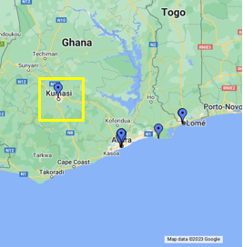

Figure 4. 4 THE MARKED-OUT AREA OF THE DESIRED ASPECT ON THE GHANA MAP.

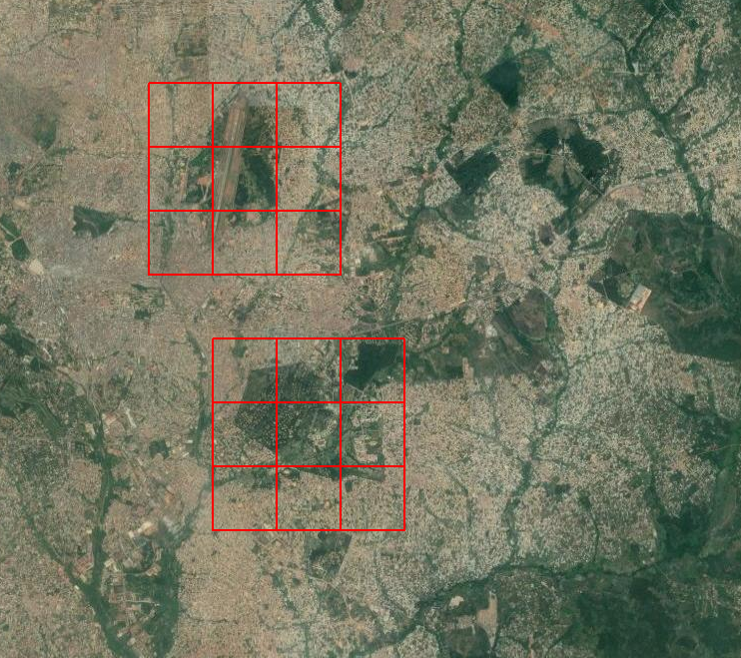

Figure 4. 5 REPRESENTS AN INNER VIEW OF THE TERRAIN WITH ZOOM LEVELS AS THE RED GRIDS.

The upper red grid represents the Kumasi airport area while the lover red grid represents the Kwame Nkrumah University of Science and Technology area. On the first try, when the images of the Kumasi airport area were generated, it turned out perfectly as required but when the satellite images of the KNUST campus area were generated, some of the images were faulty and blurry so they had to be deleted for another set of images to be extracted again. On the second try it turned out exactly as expected.

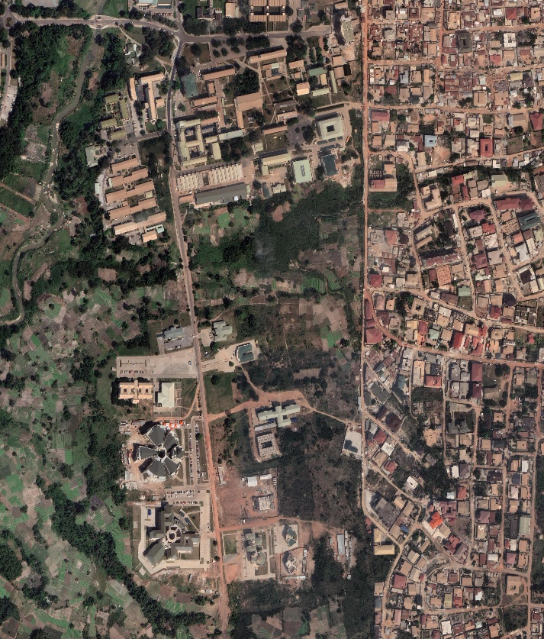

Figure 4. 6 SHOWS A PICTORIAL VIEW OF THE FACULTY AREA OF THE KNUST CAMPUS FROM THE SATELLITE.

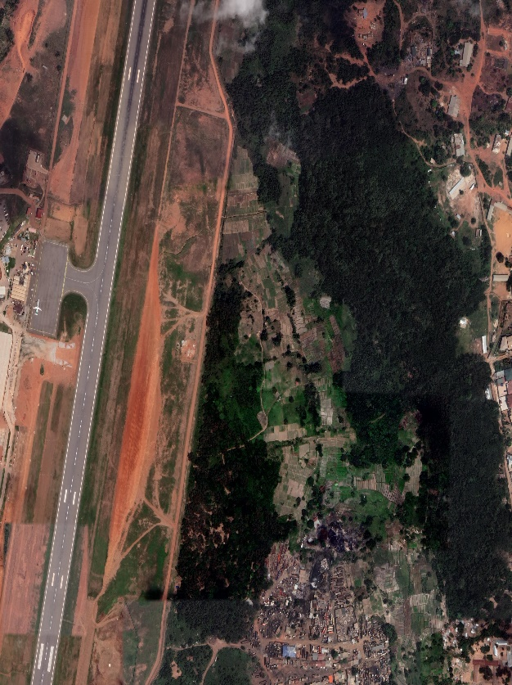

Figure 4. 7 REPRESENTS A SATELLITE IMAGE OBTAINED OF THE KUMASI AIRPORT.

### **4.3 Results from The 3D modelling in WED and Blender**

These and many more satellite images of the important area required were taken to be employed in this work. The satellite images that were obtained are 2D in nature and therefore there was the need to render them in 3D so that there is an extrusion of the figures that could be seen. This was the aspect were the World Editor and Blender software came in handy. In the use of 3D software for architectural modelling, several challenges for various aspects of the modelling were encountered some of which includes the modelling process itself, including complexity, efficiency, precision and achieving realism.

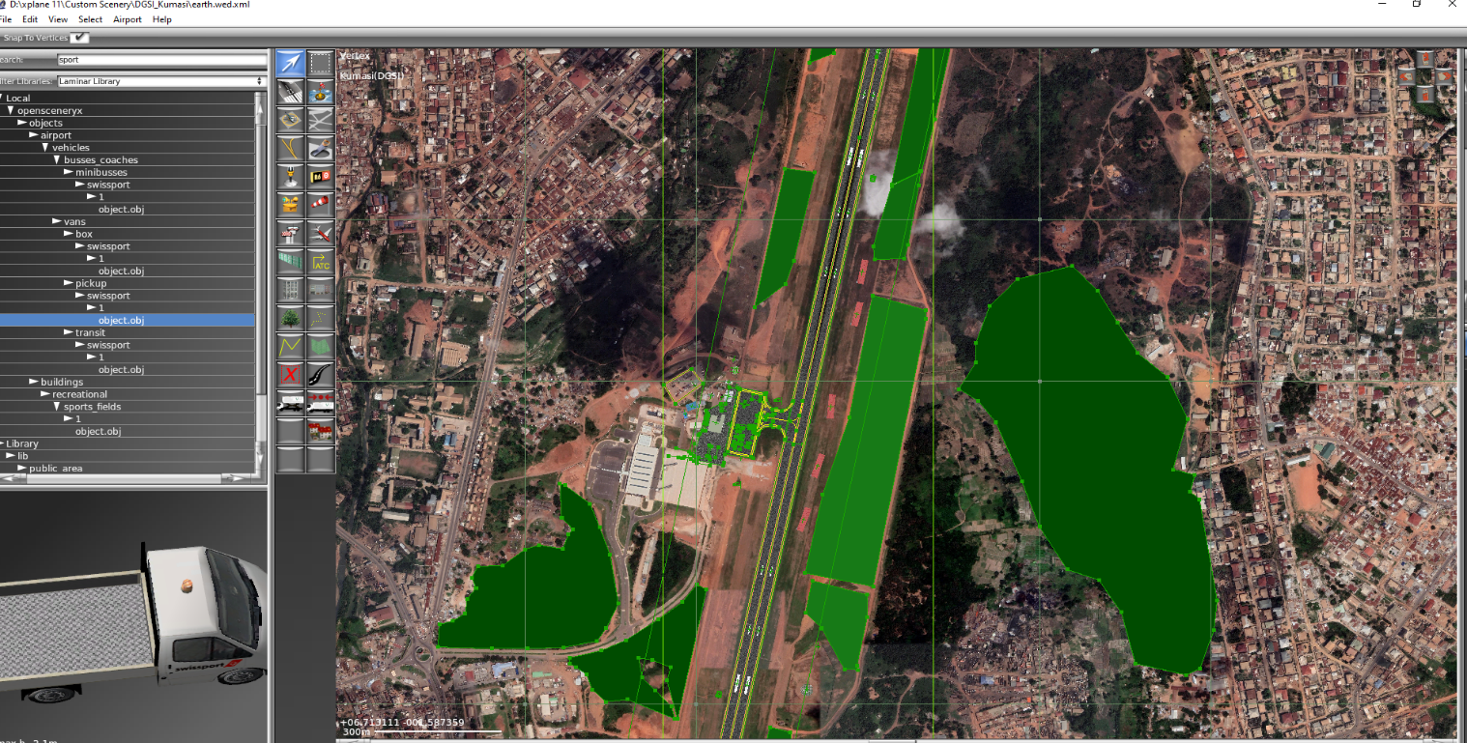

Figure 4. 8 INDICATES A 3D MODELING WORK BEING CARRIED OUT AT THE AIRPORT AREA.

It comprises of the modelling of cars, buildings, runway, trees, control tower and many more structures and objects which are likely to be found at the Kumasi Airport.

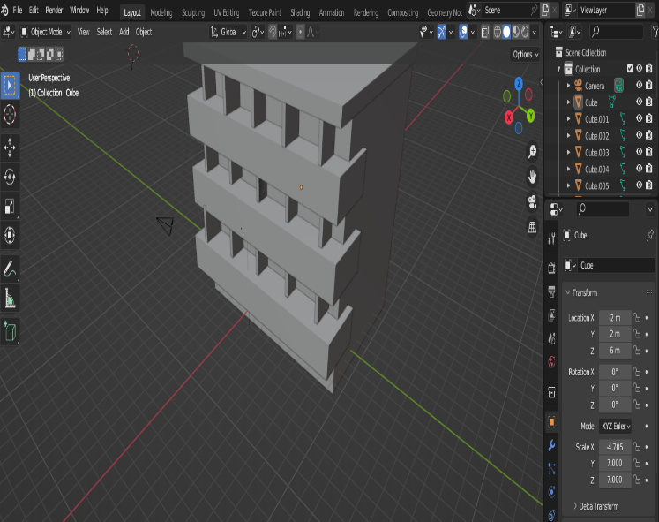

Figure 4. 9 REPRESENTS THE INITIAL STAGE OF THE 3D MODELING OF THE COLLEGE OF SCIENCE BLOCK, KNUST.

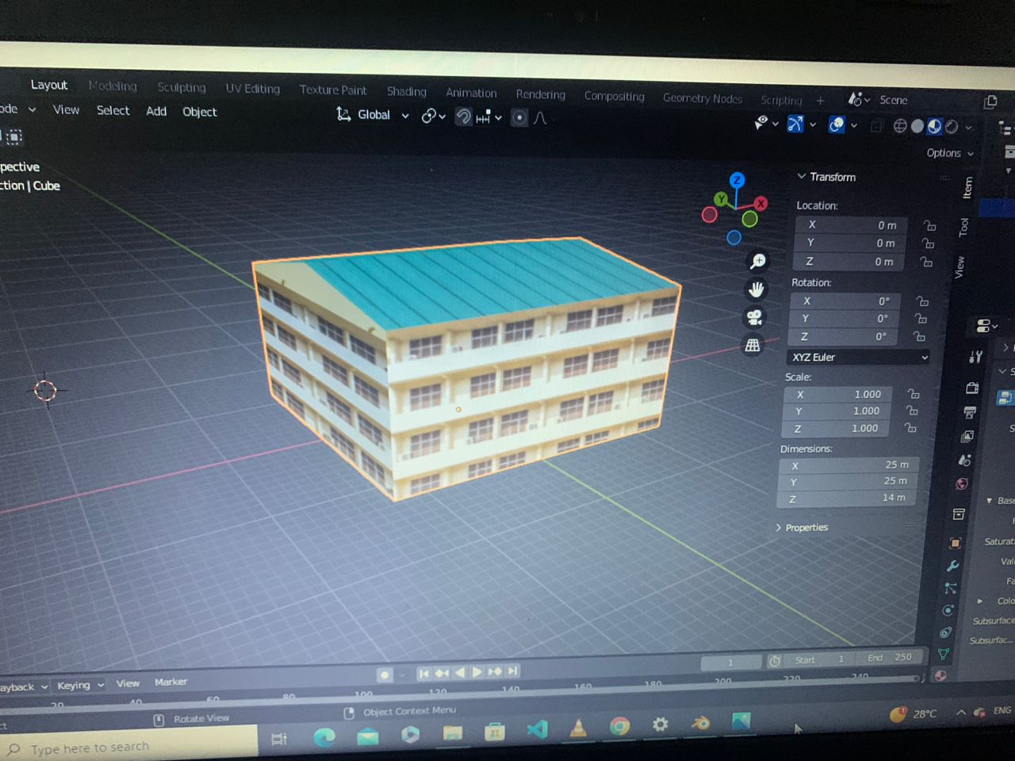

Figure 4. 10 SHOWS A COMPLETED 3D MODEL OF THE COLLEGE OF SCIENCE BLOCK, KNUST.

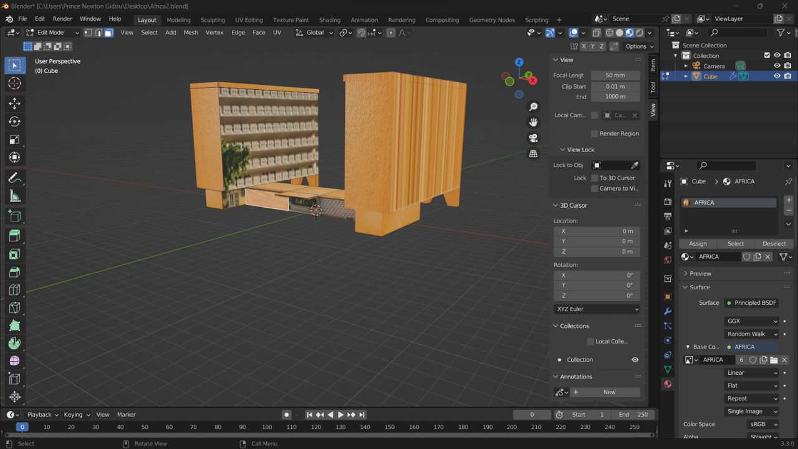

Figure 4. 11 SHOWS A COMPLETED 3D MODEL OF THE AFRICA HALL IN BLENDER SOFTWARE.

### **4.4 Geometric Optics Evaluation of Modelled Work**

The interaction of light with the buildings that were created were assessed and the geometric optics features such as reflection and casting of shadows were all done using the blender to make the work very much appreciated.

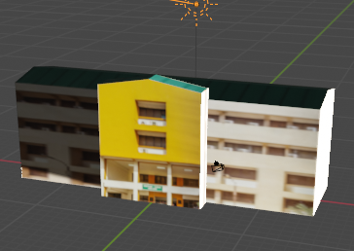

Figure 4. 12 SHOWS THE SUN AS A LIGHT SOURCE INTERACTING WITH THE 3D MODEL OF THE CASELY HAYFORD BUILDING

As it can be seen, the part of the building receiving direct sunlight casts its shadow on the other side of the building.

### **4.5 Discussion On The Testing and Debugging of The Work**

After that the objects made were tested in the X-Plane flight simulator and it happened that some of the buildings that were initially exported were miscoloured. That is, they did not mimic the actual colour that was expected, and some buildings had their structure disfigured and as such they had to be taken care of again in the blender software by remodelling them to suit the desired result. Some of the buildings were also wrongly placed in the X-Plane software.

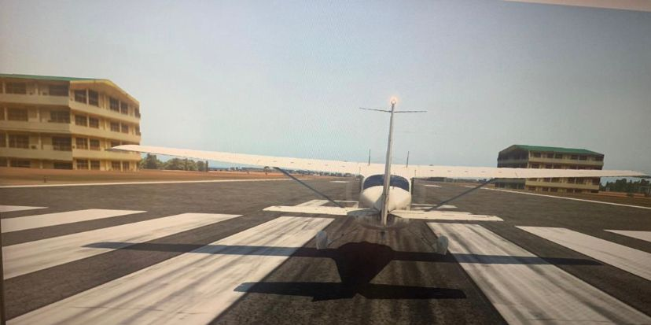

Figure 4. 13 SHOWS A WRONG PLACEMENT OF COLLEGE OF SCIENCE BUILDING RIGHT BESIDE THE RUNWAY.

This testing and debugging procedure went on for quite some time until everything met the satisfied end. The entire work was then simulated to ensure that the work was successfully done and void of any significant errors.

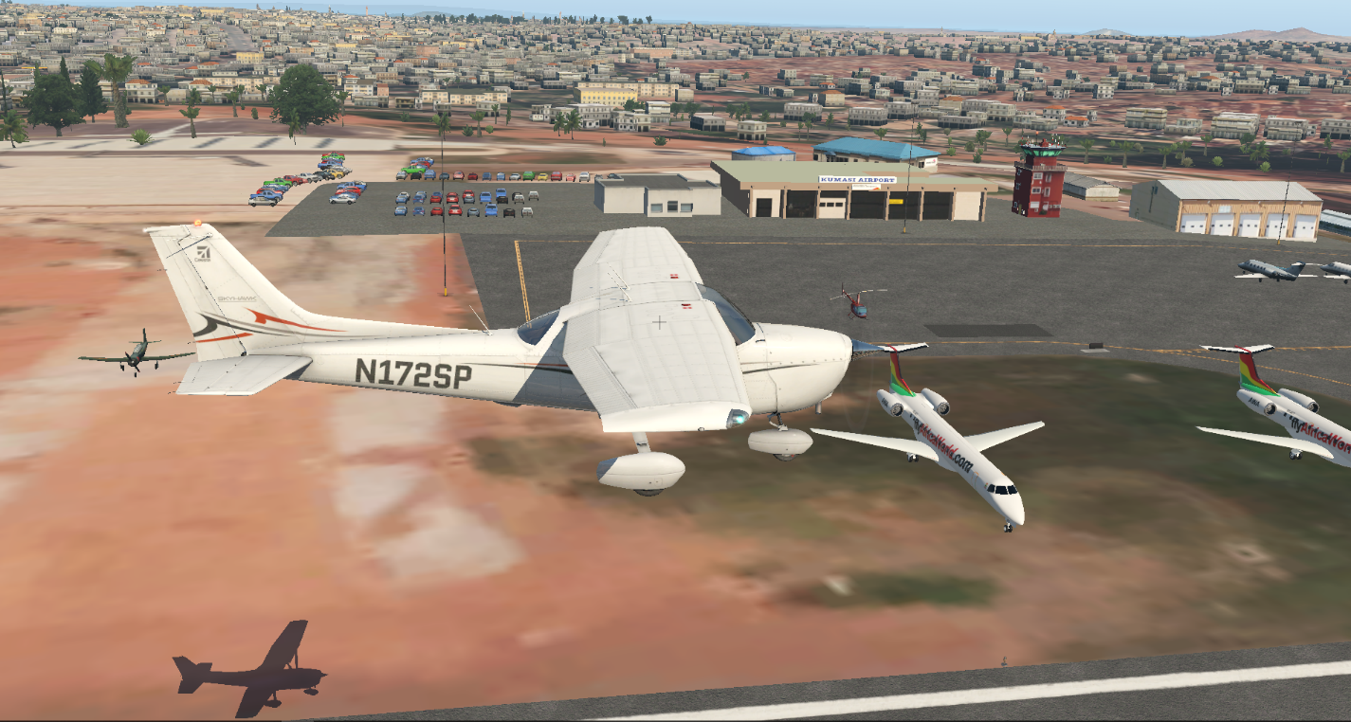

4

3

2

1

Figure 4. 14 REPRESENTS A 3D MODEL OF THE KUMASI AIRPORT IMPORTED INTO X-PLANE

The direct satellite images obtained with ortho 4xp provided a bare ground which only showed the terrain of the area. It was then necessary to model a 3D image of the area. This was done with the help of World Editor and the Blender software. Very notable objects such as the control tower (1), arrival/departure hall (2), car park area (3), aircrafts of Africa World line (Embraer ERJ-145 aircraft) (4).

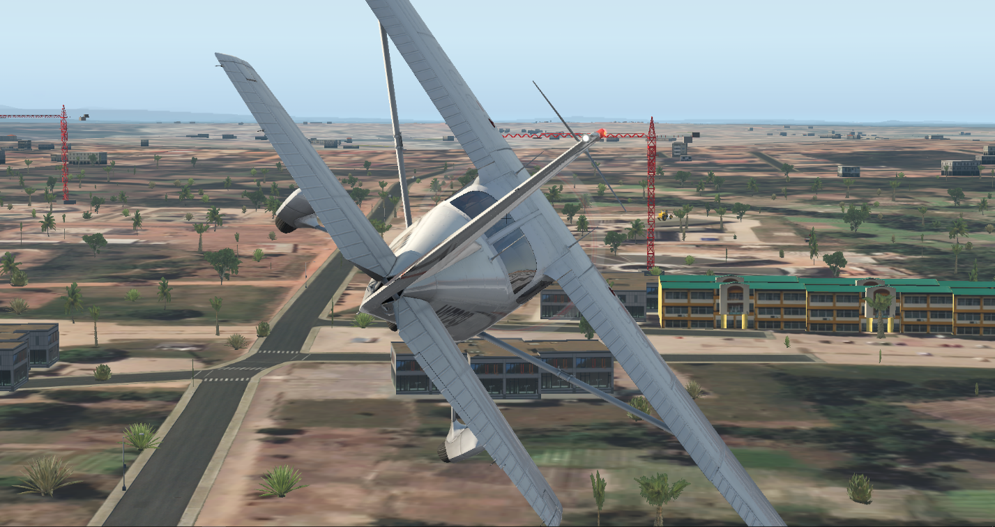

Ayim complex

Figure 4. 15 SHOWS A 3D MODEL OF THE KNUST BUSINESS SCHOOL, AYIM COMPLEX

Including significant areas like this in a flight simulator aids a pilot navigate his around campus. A landmark such as the school of business (KSB) can help trainee pilots learn to recognize important geographical features as well as other landmarks around which they will encounter in real-world flying.

# **CHAPTER 5**

## **5.1 CONCLUSION**

In this study, a comprehensive journey to model the sceneries of Kumasi, Ghana, and integrate them into the X-plane flight simulator was embarked on. The primary objective of this work was to create a 3D virtual environment that closely mimics the real-world terrain, landmarks, and structures, with a specific focus on Kumasi Airport and the Kwame Nkrumah University of Science and Technology (KNUST) campus. This goal was achieved through a series of carefully planned steps, employing various software tools such as Ortho4XP, World Editor, Blender, and X-Plane. Efforts were driven by the recognition that an immersive and accurate virtual environment plays a vital role in enhancing flight training and simulation experiences. Such environments offer not only an opportunity for students and aspiring pilots to bridge the gap between theoretical knowledge and practical application but also a platform for refining decision-making and problem-solving skills and essential attributes for success in the aerospace industry. Throughout the course of this work, several challenges were encountered, including the extraction and processing of satellite imagery, 3D modelling complexities, and the intricacies of lighting and reflection in the virtual environment. However, with dedication and iterative testing and debugging, all these challenges were successfully overcome to produce a realistic and functional representation of Kumasi's sceneries. This survey results from aerospace engineering students at Kwame Nkrumah University of Science and Technology (KNUST) and interviews with experienced pilots reinforced the importance of this work. Respondents expressed their enthusiasm for the integration of realistic sceneries into flight simulators, recognizing the significant benefits it can offer in terms of practical learning, situational awareness, and the overall quality of flight training. This work underscores the relevance and value of incorporating accurately modelled sceneries into flight simulators. This work will not only contribute to the aviation industry but also serves as an educational resource for both students and aviation professionals. The immersive experiences provided by the virtual environments have the potential to enhance pilot training, improve decision-making skills, and ultimately contribute to safer and more effective flight operations. As technology continues to advance, the flight simulation community remains dynamic and thriving, with opportunities for further innovation and refinement. This work is trusted to inspire continued exploration and development in the field of flight simulation scenery modelling.

## **5.2 RECOMMENDATIONS**

The work undertaken employed some great tools and resources like the Blender software and ortho4XP to aid in the integration of the Ghanaian scenery and landmark into the X-Plane flight simulator. There are a number of ways in which some individuals in times past have integrated real life sceneries into the X-Plane flight simulator but the procedure utilized in carrying out this work has proven to be very reliable and trusted way in mimicking the real world. This is because some people make use of photoshop in trying to get the buildings and several other structures to imitate the ones in real life but the advantage of blender modelling is that one is able to first start the making of the solid structure of the building first before proceeding to add the texture of the building to it and this gives it some good degree of virtual imitation. It must be noted that the nature of some buildings can sometimes be an arduous task to complete in the blender software but with much dedication and persistence one can definitely come through till the end of it.

For individuals who have interests in making a virtual scenery of any city or town, there are a number of cues and ideas that can be obtained from this work in making a more detailed and enhanced virtual scenery of a place. The google satellite images obtained have also been a genuinely good source of image for this kind of task. It must be noted that for building textures that are not free on the internet one would have to pay some amount of money to be able to use some textures which other individuals are selling online.

It is advised that for future advancement of this kind of work, one must have ample storage which will be enough to store the data will be generated from the satellites for the images since the images of the terrain with high detail occupy a lot of storage space. Also, one must work with a machine with high specifications. That is, a RAM of not less than 16GB, a graphics card a DirectX 12-capable video card from NVIDIA or AMD with at least 4GB of VRAM, a CPU like intel core i5 or better, and an OS of Windows 10 or higher. Thus, making the execution of your task easier and able to run faster as required without machine lagging.

# **REFERENCES**

1. Allerton, D. (2009). *Principles of Flight Simulation (Aerospace Series (PEP))*. *27*.
2. Atsuyo Ito. (2011, April 11). *Legal Aspects of Satellite Remote Sensing - Atsuyo Ito - Google Books*. https://books.google.com.gh/books?id=rfN5DwAAQBAJ&newbks=1&newbks_redir=0&printsec=frontcover&dq=how+the+satellite+uses+remote+sensing+to&hl=en&redir_esc=y#v=onepage&q&f=false
3. Banks, C. (2000). *A DISCUSSION OF METHODS OF REAL-TIME AIRPLANE FLIGHT SIMULATION*.
4. Brittany Vincent. (2023). *Microsoft® Flight Simulator For Dummies® ANY IMPLIED WARRANTIES OF MERCHANTABILITY OR FITNESS FOR A*. http://www.wiley.com/go/permissions.
5. Chu, E. W., & Karr, J. R. (2017). Environmental Impact: Concept, Consequences, Measurement. *Reference Module in Life Sciences*. https://doi.org/10.1016/B978-0-12-809633-8.02380-3
6. Criminisi, A., Kang, S. B., Swaminathan, R., Szeliski, R., & Anandan, P. (2005). Extracting layers and analysing their specular properties using epipolar-plane-image analysis. *Computer Vision and Image Understanding*, *97*(1), 51–85. https://doi.org/10.1016/J.CVIU.2004.06.001
7. Farmer, E., Van Rooij, J., Riemersma, J., Jorna, P., & Moraal, J. (2017). Handbook of simulator-based training. *Handbook of Simulator-Based Training*, 1–364. https://doi.org/10.4324/9781315253671
8. *How images are collected - Google Earth Help*. (2015). https://support.google.com/earth/answer/6327779?hl=en
9. Jentsch, F., Curtis, M., & Salas, E. (2017). *Simulation in aviation training*.
10. Koglbauer, I. V., & Biede-Straussberger, S. (2021). *Aviation Psychology: Applied Methods and Techniques*. Hogrefe Verlag GmbH & Co.KG. https://graz.elsevierpure.com/en/publications/aviation-psychology-applied-methods-and-techniques
11. Kramer, L. J., & Busquets, A. M. (2000). *Comparison of Pilots ’ Situational Awarenes s While Monitorin g Autoland Approach es Using Conventio nal and Advanced Flight Display Formats*. http://www.sti.nasa.g
12. Latifi, S. (2021). *ITNG 2021 18th International Conference on Information Technology-New Generations*.
13. Lazic, D. A., Grujic, V., & Tanaskovic, M. (2022a). The role of flight simulation in flight training of pilots for crisis management. *South Florida Journal of Development*, *3*(3), 3624–3636. https://doi.org/10.46932/sfjdv3n3-046
14. Lazic, D. A., Grujic, V., & Tanaskovic, M. (2022b). The role of flight simulation in flight training of pilots for crisis management. *South Florida Journal of Development*, *3*(3), 3624–3636. https://doi.org/10.46932/sfjdv3n3-046
15. Liu, G., Rodgers, J., Milne, S., Rowland, M., Mcintosh, B., Best, M., Lepinard, O., Hanham, M., January, ·, & Martin, J. (2019). *Eyes on U: Opportunities, Challenges, and Limits of Remote Sensing for Monitoring Uranium Mining and Milling*. www.miis.edu
16. *Mapbox.com*. (2010). https://www.mapbox.com/insights/satellite-imagery
17. Mayer, V. J. (1995). Using the earth system for integrating the science curriculum. *Science Education*, *79*(4), 375–391. https://doi.org/10.1002/SCE.3730790403
18. Mustafa, W. A., & Yazid, H. (2017). *Image Enhancement Technique on Contrast Variation: A Comprehensive Review Non destructive testing and evaluation View project Document Image Analysis View project Image Enhancement Technique on Contrast Variation: A Comprehensive Review*. https://www.researchgate.net/publication/320322102
19. Perry, A. R. (2004). *The FlightGear Flight Simulator*. 1–12.
20. Ramirez, E. J., & LaBarge, S. (2018). Real moral problems in the use of virtual reality. *Ethics and Information Technology*, *20*(4), 249–263. https://doi.org/10.1007/S10676-018-9473-5/METRICS
21. Ranabhat Sharad. (2023). *The World of Flight Simulators – Airways*. https://airwaysmag.com/flight-simulators/
22. Ray L. (2000). *Brief History of Flight Simulation*. 11–17.
23. Rolfe, J. M., & Staples, K. J. (1988). *Flight simulation*. 282.
24. Sazid Mahammad sazid, S., & Ramakrishnan, R. (2003). *GeoTIFF-A standard image file format for GIS applications*.
25. Schennetten, K., Meier, M. M., Scheibinger, M., Meerkötter, R., Jiao, P., & Wang, L. (2018). *Research on Virtual Visualization Technology of Flight Simulation You may also like Measurement of UV radiation in commercial aircraft Usability Evaluation Survey for Identifying Design Issues in Civil Flight Deck Negin Ozve Aminian, Fairuz Izzuddin Romli and Surjatin Wiriadidjaja-Validation of a radiative transfer model with measurements of UV radiation inside a commercial aircraft Research on Virtual Visualization Technology of Flight Simulation*. *452*(4). https://doi.org/10.1088/1757-899X/452/4/042206
26. *Simulation vs. Visualization - what’s the difference? - Visual Components*. (2017, May 11). https://www.visualcomponents.com/resources/blog/simulation-vs-visualization-difference/
27. Utrilla, B. M. (2017). *FLIGHT SIMULATOR DEVELOPMENT WITH SAFETY SYSTEM IMPLEMENTATION*. 9.
28. West, J. Van, & Lane-Cummings, K. (2007). *MICROSOFT MICROSOFT ® ® FLIGHT SIMULATOR X FOR PILOTS: FLIGHT SIMULATOR X FOR PILOTS: REAL-WORLD TRAINING REAL-WORLD TRAINING*.
29. *What is 3D modelling and what is it used for? - FutureLearn*. (2022, March 18). https://www.futurelearn.com/info/blog/general/what-is-3d-modelling